**Chapter 1**

**SYSTEM ANALYSIS**

System analysis is the “Process of studying a procedure or business in order to identify its goals and purposes and create systems and procedures that will achieve them in an efficient way”. System Analysis can also be viewed as a problem-solving technique that breaks down a system into its component pieces for the purpose of the studying how well those component parts work and interact to accomplish their purpose.

System analysis professionals are often called upon to look critically at systems, and redesign or recommend changes as necessary. System analysts help to evaluate whether a system is viable or efficient within the context of its overall architecture, and help to uncover the options available to the employing or other party.

In order to find out the required information we surfed through the different websites available on the internet. We also analysed other similar systems and recorded their common behaviour. We presented a new system that would make life easier, systematic and more efficient for the students moving to Goa.

* 1. **Introduction**

In this modern era which is filled with advanced technology, one can expect to find each and everything possible online, whether it is buying a product, searching for a restaurant or getting the latest news. In our project, we have developed a web-based system exclusively for the students who are pursuing their studies in Goa, which will allow them to cater to their respective needs without much hassle.

Student facilitation System is a web-based system which allows the students to access their basic needs at their convenience in just one click. You need not go personally to find out about the facilities that are available in different parts of the area especially when one is unknown to the surrounding. This saves a lot of time and money. This system is important for those students, who in most cases are non Goans, who are unaware of the place and the language. It helps in overcoming the language barrier as the students get all the essential information on the site.

This is a user-friendly system which is easy to access and does not complicate matters. The services that are shown on the website are genuine and not fraudulent as they are checked in advance before being put up on the site.

* 1. **Existing system and its limitations**

Presently we just have sites displaying classified advertisements, no system exists that solves all the user needs in one location. While some sites cater to only mess facilities or laundry services, others are primarily to find accommodation. No system exists that caters to students w1/2here they can search for facilities in the vicinity of the college they go to.

The limitations of the existing system are:

* **Time Consuming**

Due to the existing system, the students are inconvenienced as most of the basic facilities they need are not found together in one place. Students may have to travel to different places in order to find the services they need.

* **Language Barrier**

In the existing system, the students have to personally meet the owners in order to get all the required information of the services provided. The students most of them being non Goans are unable to understand the language that is spoken by the owner.

* **Monopoly of the institute**

In the existing system, students from a particular institute must use the facilities that are available in the premises of the institute. They are unaware of the services available elsewhere which could be better and cheaper.

* **Genuine owners**

The students are often shocked to see the actual facilities provided as the online pictures may be totally different from reality.

* 1. **Proposed Systems**

‘Web based Student’s facilitation System’ was developed keeping in mind the student community who may have shifted to Goa to complete their studies.

The features of the proposed system are:

* **Student Accommodation**

In our proposed system the student will get to check out the different types of rental premises available along with their charges and the facilities provided by the owner. The students can book the room by filling the necessary details asked and can do the payment after meeting the owner.

* **Mess Facilities**

Students will be able to find out the different types of food and prices of the available messes registered on the sites in the area they need. They can specify the day and time on which the food is required either as a room service or in the mess. The students can also do cash on delivery for the room services provided.

* **Laundry Services**

Students living on their own will usually require laundry services. Through this module students will get to know the different laundry services available in their vicinity. The student can assign a particular day and time according to their convenience when they require the laundry service. The payment will be done after the particular services are rendered.

* **Medical Assistance**

Whenever the students are in need of medical assistance, they will be able to search online for the nearby clinics and the hospitals. They can also get the required information about the doctors pertaining to their degree, speciality, time or days when the doctor will be available.

* **Coaching Classes**

The site will provide the students with information of all the different coaching classes that are available in the vicinity of their college.

* **Feedback**

Students will be able to give feedback about the services displayed on the website. This will help other students before they make a decision to use that service.

**Chapter 2**

**SYSTEM DESIGN**

After a detailed analysis of **‘Web based Student’s facilitation System’** we established certain facts that have to be handled to improve and enhance our system. First and foremost we classified the stable processes that are efficient enough and do not require too many redesigns, once all the stable processes were defined, we shifted our focus to the processes that are needed to be restructured to enhance the overall system performance.

In order to model the system structure, we identified the entities involved in our system and learnt the inter-connecting relationships amongst them. The data that defines the entities is expressed through its attributes. We also figured out the number of instances of every entity that is involved in the relationship. The number of instances defined the importance of the entity in the relationship. To model these structures we drew an entity relationship diagram.

We have realized that our system is not static and it contains behaviours that causes change to it, these behaviours are modelled as activities. They are several entities involved in changing the behaviour of the system. We took every entity and understood its role in the system. Most often the bottlenecks in the system performance occurred due to overloading of responsibilities onto some entities whilst keeping the others unutilized. Such behaviours were expressed through an activity diagram.

Once we captured the static structure and the dynamic behaviour of the system we remodelled it to complete the internal redesigning of the system. Then we shifted our focus onto the external interfaces and the different external entities that influenced our system. We defined separate use cases that act as interface points and mapped them to the internal process in the system. We classified and grouped similar entities and defined them in terms of a role they play in the system. The various cases and their interfacing users were expressed through a use case diagram.

**2.1 Entity Relationship Diagram**

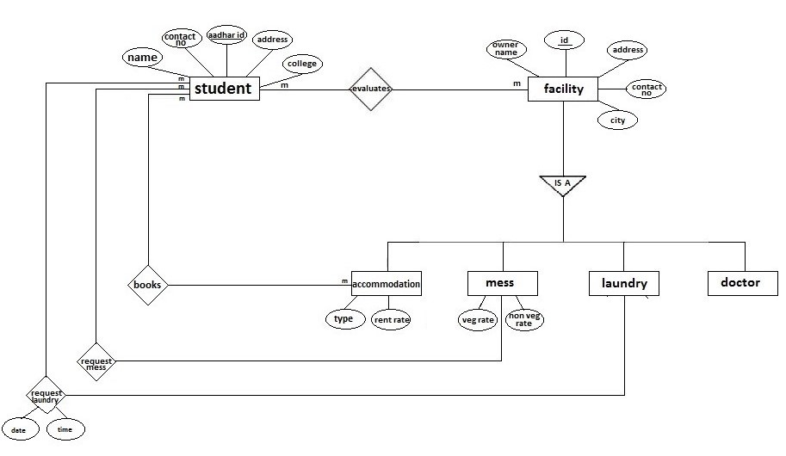

Figure 2.1: Entity Relationship Diagram for the system.

**2.2 Use case diagram**

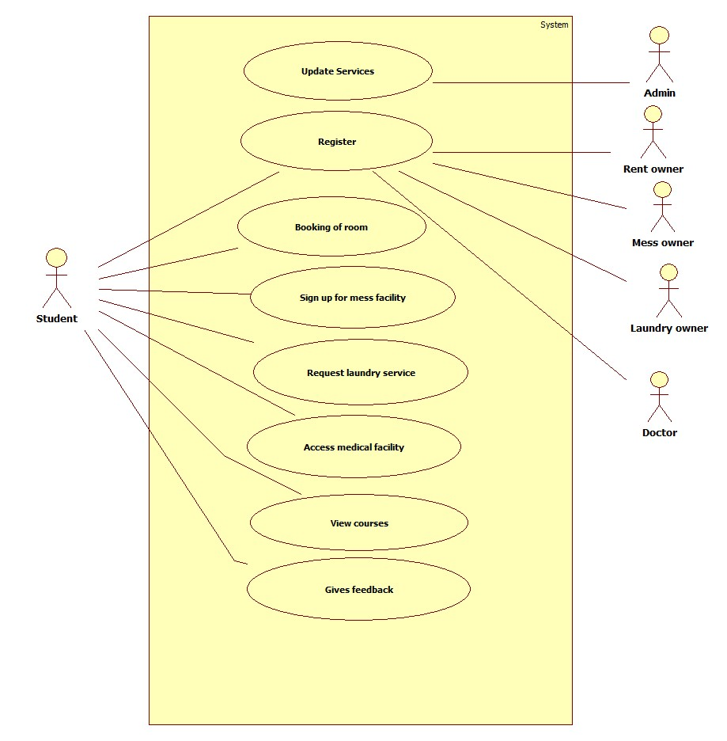

Figure 2.2: Use case diagram for the system

**2.3 Activity Diagram**

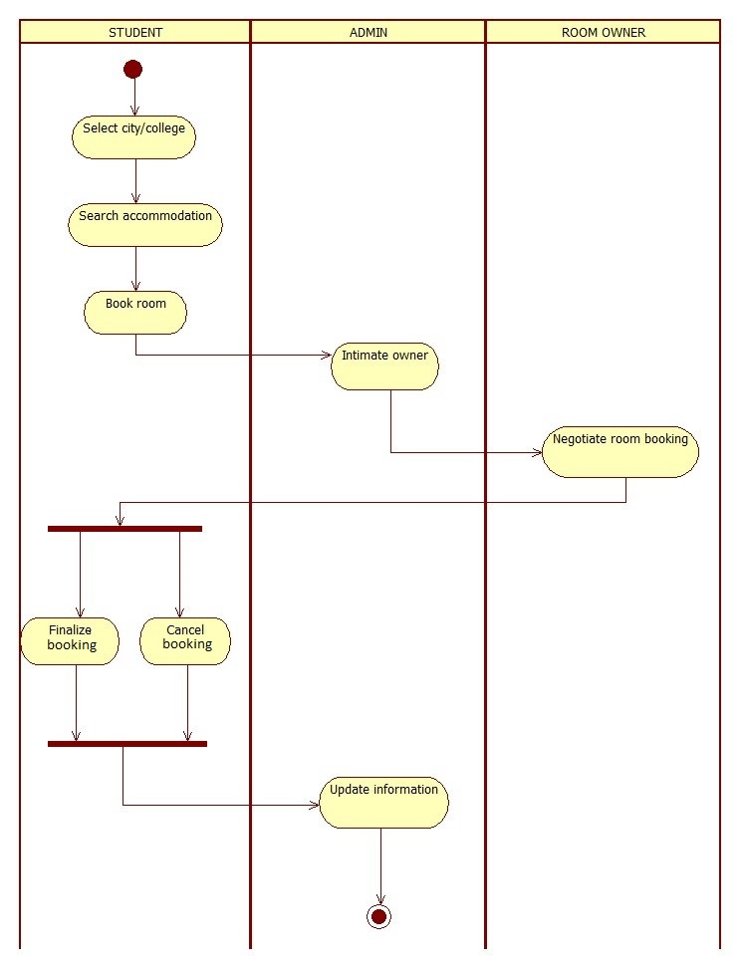

Figure 2.3.1:Activity diagram for Room booking

**Chapter 3**

**SYSTEM IMPLEMENTATION**

Implementation is the carrying out or execution of a plan, method, or any design for doing something. In computer science, an implementation is a realization of a technical specification or algorithm as a program, software component, or other computer system through computer programming and deployment.

After a thorough analysis and design of our system we started with the system implementation phase.We decided to implement the system as a web application over the internet. A web application is hosted on a web server on the internet and is accesses by users as clients though a web browser.

The front end is implemented through web pages and web forms. The various tools available for implementing a user friendly interface are used to enhance the user experience. At the same time utmost care has been taken to follow standard rules and universally acceptable conventions governing software user interfaces.

The web server apart from hosting the application also runs a database that provides back end storage support to the system. The database supports multiuser access and through SQL makes it possible for querying the data through and from the application.

**3.1 Implementation Tools**

After identifying the problem with the existing system we designed a solution and proposed to implement it through software. The software is a web application and hosted onto a web server on the internet. Taking into account the technical feasibility of the system we have used the following web technologies in the implementation of the software.

**Front End Software Tools**

* **Markup Language**

Hypertext Markup language (html) is used to Markup the layout of the pages and forms. We have used frames, tables, Meta tags and other formatting tags to Markup the front end.

Version: HTML 4.0

* **Styling**

Cascading style sheets (CSS) , is used to style the markup. CSS provides a core functionality of the front-end development, the styles that lay out the pages and give it both its unique visual flair and a clear, user-friendly view to users

Version: CSS 3.0

* **Scripting**

JavaScript has been used as a client side scripting language for validations. JavaScript supports inline scripting and/or external scripting, thereby adding programming functionality in html.

Version: JavaScript 1.8

* **Browser**

The client side functionality has been tested on Mozilla Firefox

Version: Mozilla 26.0/ Internet Explorer 9.0

**Backend software tools**

* **Scripting**

PHP: Hypertext pre-processor being a popular general-purpose scripting language and matching our requirements we have used it for our server side scripting.

Version: PHP 5.4.0

* **Database**

Mysql is a popular choice of database for use in web applications. Due to its support for multiple users and robust processing it suited well for our requirements and being an open source software was an obvious choice.

Version: Mysql 5.7.14

* **Web server**

The server is implemented on an apache server through XAMP

Version: Apache V2.2

**Chapter 4**

**SYSTEM TESTING**

Falling under the scope of black box testing, system testing is a phase in the software testing cycle where the total integrated application/system is tested. The focus of system testing is to evaluate the compliance of the entire system with respect to the specified requirements. System testing helps in approving and checking the business, functional, technical and any non-functional requirements of the application concerning the architecture as a whole.

The scope of the system testing is not only limited to the design of the system but also to the behaviour and believed expectations of the business. In accordance with the software test cycle, system testing is performed before acceptance testing and after integration testing. Independent users or testers are given the tasks to perform in the system testing phase.

Some of the importance aspects of system testing are:

* Proper evaluation of the system meeting the functional requirements is done in system testing.
* Validation, verification and testing of business requirements and application architecture is done during the system testing phase.
* System testing provides users with an effective environment which more or less resembles the live or production environment.

**4.1 Validation Test Report**

|  |  |
| --- | --- |
| Report : | I |
| Project : | Web based Student’s facilitation System |
| Module : | Login Form. |
| Referencing from : | Home Page |
| Functional Specification : | Login for administrator. |
| Test Date : | 21/01/2019 |
| Test Objective : | To validate the login form. |

|  |  |  |  |  |  |
| --- | --- | --- | --- | --- | --- |
| **Test Case No.** | **Event** | **Input Data** | **Expected Output** | **Actual Output** | **Result** |
| 1 | Enter your name and press submit button | User name=” ” | Should display warning message box “Please enter user name” | Displays warning message box “Please enter user name” | Success |
| 2 | Enter Password and press  submit button | Password=” ” | Should display warning message box “please enter your Password” | Displays warning message box “please enter your Password” | Success |
| 3 | Enter user name and password and press submit button | User name=””  Password=” ” | Should display warning message box “please enter your user name and password” | Displays warning message box “please enter your user name and password” | Success |

Table 4.1: Validation report of the login form.

|  |  |
| --- | --- |
| Report : | II |
| Project : | Web based Student’s facilitation System |
| Module : | To register a Business/ Service |
| Referencing from : | Home Page |
| Functional Specification : | To register the business on the site |
| Test Date : | 21/01/2019 |
| Test Objective : | To validate the business registration |

|  |  |  |  |  |  |
| --- | --- | --- | --- | --- | --- |
| **Test Case No.** | **Event** | **Input Data** | **Expected Output** | **Actual Output** | **Result** |
| 1 | Enter your name and press register button | User name=” ” | Should display warning message box “please enter your name” | Displays warning message box “please enter your name” | Success |
| 2 | Enter address and press register button | Address=”” | Should display warning message box “please enter your address” | Displays warning message box “please enter your address” | Success |
| 3 | Enter Aadhar ID and press register button | Aadhar ID=  “” | Should display warning message box “please enter your Aadhar ID ” | Displays warning message box “please enter your Aadhar ID” | Success |
| 4 | Enter contact number and press register button | Contact=”333” | Should display warning message box “please enter correct Contact no.” | Displays warning message box “please enter correct Contact no.” | Success |
| 5 | Select the city and press register button | City=”” | Should display warning “Please select the city” | Displays warning “Please select the city” | Success |
| 6 | Select type of services and press register button | Services=”” | Should display warning “Please select the type of service” | Displays warning “Please select the type of service” | Success |
| 7 | Enter Business details and press register button | Business details=”” | Should display warning “Please enter business details” | Displays warning “Please enter business details | Success |

Table 4.2: Validation report of the business registration form.

|  |  |
| --- | --- |
| Report : | III |
| Project : | Web based Student’s facilitation System |
| Module : | Contact form |
| Referencing from : | Home Page |
| Functional Specification : | To allow users to contact the admin |
| Test Date : | 21/01/2019 |
| Test Objective : | To validate the contact form |

|  |  |  |  |  |  |
| --- | --- | --- | --- | --- | --- |
| **Test Case No.** | **Event** | **Input Data** | **Expected Output** | **Actual Output** | **Result** |
| 1 | Enter your name and press submit button | User name=”” | Should display warning message box “please enter your name” | Displays warning message box “please enter your name” | Success |
| 2 | Enter  E-mail and press submit button | E-mail=  ”docgmail  .com” | Should display warning message box “please enter correct E-mail ID” | Displays warning message box “please enter correct E-mail ID” | Success |
| 3 | Enter contact number and press submit button | Contact number  =”4869 ” | Should display warning message box “please enter correct no.” | Displays warning message box “please enter correct contact no.” | Success |
| 4 | Enter the message and press submit button | Message=” ” | Should display warning message box “please enter your Message” | Displays warning message box “please enter your Message” | Success |

Table 4.3: Validation report of the contact form.

|  |  |
| --- | --- |
| Report : | IV |
| Project : | Web based Student’s facilitation System |
| Module : | Feedback form |
| Referencing from : | Home Page |
| Functional Specification : | To allow users to provide Feedback |
| Test Date : | 21/01/2019 |
| Test Objective : | To validate the Feedback form |

|  |  |  |  |  |  |
| --- | --- | --- | --- | --- | --- |
| **Test Case No.** | **Event** | **Input Output** | **Expected Output** | **Actual Output** | **Result** |
| 1 | Enter your name and press submit button | User name=” ” | Should display warning message box “please enter your name” | Displays warning message box “please enter your name” | Success |
| 2 | Enter  E-mail and press submit button | E-mail=” ” | Should display warning message box “please enter your E-mail” | Displays warning message box “please enter your E-mail” | Success |
| 3 | Enter contact number and press submit button | Contact  =”9876 ” | Should display warning message box “please enter correct Contact no.” | Displays warning message box “please enter correct Contact no.” | Success |
| 4 | Enter Subject and press submit button | Subject=”” | Should display warning message box “please enter the Subject” | Displays warning message box “please enter the Subject” | Success |
| 5 | Enter feedback and press submit button | Message=” ” | Should display warning message box “please enter your Message” | Displays warning message box “please enter your Message” | Success |

Table 4.4: Validation report of the feedback form.

|  |  |
| --- | --- |
| Report : | V |
| Project : | Web based Student’s facilitation System |
| Module : | Room booking |
| Referencing from : | Room Page |
| Functional Specification : | Register to book room |
| Test Date : | 21/01/2019 |
| Test Objective : | To validate the room register form |

|  |  |  |  |  |  |
| --- | --- | --- | --- | --- | --- |
| **Test Case No.** | **Event** | **Input Data** | **Expected Output** | **Actual Output** | **Result** |
| 1 | Enter your name and press submit button | User name=” ” | Should display warning message box “please enter your name” | Displays warning message box “please enter your name” | Success |
| 2 | Enter gender and press confirm | Gender=”” | Should display warning message box “please select your Gender” | Displays warning message box “please select your Gender” | Success |
| 3 | EnterE-mail and press confirm button | E-mail  =”jclgmail.com ” | Should display warning message box “please enter correct E-mail ID” | Displays warning message box “please enter correct E-mail ID” | Success |
| 4 | Enter contact number and press confirm button | Contact  =”543 ” | Should display warning message box “please enter correct Contact no.” | Displays warning message box “please enter correct Contact no.” | Success |
| 5 | Enter Aadhar- ID/  Passport number and press confirm button | Aadhar ID/Passport no=  “ ” | Should display warning message box “please enter your Aadhar ID/Passport no ” | Displays warning message box “please enter your Aadhar ID/Passport no” | Success |
| 6 | Enter college/University name and press confirm button | College/University =” ” | Should display warning message box “please enter your College/University name” | Displays warning message box “please enter your College/University name” | Success |
| 7 | Select room code and press confirm button | Room code=”” | Should display warning message box “please select Room code” | Displays warning message box “please select Room code” | Success |

Table 4.5: Validation report of the room form.

|  |  |
| --- | --- |
| Report : | VI |
| Project : | Web based Student’s facilitation System |
| Module : | Laundry service booking |
| Referencing from : | Laundry Page |
| Functional Specification : | To avail Laundry service |
| Test Date : | 21/01/2019 |
| Test Objective : | To validate the Laundry service form |

|  |  |  |  |  |  |
| --- | --- | --- | --- | --- | --- |
| **Test Case No.** | **Event** | **Input Data** | **Expected Output** | **Actual Output** | **Result** |
| 1 | Enter your name and press submit button | User name=” ” | Should display warning message box “please enter your name” | Displays warning message box “please enter your name” | Success |
| 2 | Enter contact number and press confirm button | Contact=” ” | Should display warning message box “please enter your Contact” | Displays warning message box “please enter your contact” | Success |
| 3 | Enter address and press confirm button | Address=”” | Should display warning message box “please enter your address” | Displays warning message box “please enter your address” | Success |
| 4 | Enter college/University name and press confirm button | College/University =” ” | Should display warning message box “please enter your college/University name” | Displays warning message box “please enter your college/University name” | Success |
| 5 | Select laundry code and press confirm button | Laundry  Code =” ” | Should display warning message box “please enter your laundry code” | Displays warning message box “please enter your laundry code” | Success |
| 6 | Select the Date and press confirm button | Date=” ” | Should display warning message box “please select the date” | Displays warning message box “please select the date” | Success |
| 7 | Select the Time and press confirm button | Time=” ” | Should display warning message box “please select the time” | Displays warning message box “please select the time” | Success |

Table 4.6: Validation report of the Laundry form.

|  |  |
| --- | --- |
| Report : | VII |
| Project : | Web based Student’s facilitation System |
| Module : | Mess service booking |
| Referencing from : | Mess Page |
| Functional Specification : | To avail Mess service |
| Test Date : | 21/01/2019 |
| Test Objective : | To validate the Mess service form |

|  |  |  |  |  |  |
| --- | --- | --- | --- | --- | --- |
| **Test Case No.** | **Event** | **Input Data** | **Expected Output** | **Actual Output** | **Result** |
| 1 | Enter your name and press submit button | User name=” ” | Should display warning message box “please enter your name” | Displays warning message box “please enter your name” | Success |
| 2 | Enter number E-mail and press confirm button | E-mail =” ” | Should display warning message box “please enter your E-mail” | Displays warning message box “please enter your E-mail” | Success |
| 3 | Enter contact and press confirm button | contact =”” | Should display warning message box “please enter your Contact” | Displays warning message box “please enter your contact” | Success |
| 4 | Enter Aadhar ID/Passport number and press confirm button | Aadhar ID/Passport no=  “ ” | Should display warning message box “please enter your Aadhar ID/Passport number” | Displays warning message box “please Aadhar ID/Passport number” | Success |
| 5 | Enter college/University name and press confirm button | college/University =” ” | Should display warning message box “please enter your college/University | Displays warning message box “please enter your college/University” | Success |
| 6 | Select the Caterer and press confirm button | Caterer=” “ | Should display warning message box “please select caterer” | Displays warning message box “please select caterer” | Success |
| 7 | Enter the food service and press confirm button | Food service=” ” | Should display warning message box “please select the food service” | Displays warning message box “please select the food service” | Success |
| 8 | Select the Date and press confirm button | Date=” ” | Should display warning message box “please select the date” | Displays warning message box “please select the date” | Success |

Table 4.7: Validation report of the Mess form.

**Chapter 5**

**USER MANUAL**

**Website:** Web based Student’s facilitation System

**Version:**1.0

**Hardware requirements:**

|  |  |
| --- | --- |
| * Processor: | 32/64-bit, 1GHz minimum per core |
| * RAM: | 4GB for developer and evaluation use |

**Software Requirements:**

|  |  |
| --- | --- |
| * Operating System: | Microsoft Windows 7, 8 &10.1 |
| * Web Server Software: | Apache v2.2+ |
| * Scripting Language: | PHP v5.2.2.12+/ Java |
| * Database: | MYSQL Server v5.1+ |
| * Web Brower Software: | Mozilla Firefox / Internet Explorer |

**User Experience level:**

Basic knowledge of Web surfing desirable

**About:**

The site is a web application designed for **WEB BASED STUDENT’S FACILITATION SYSTEM**

**Form: I**

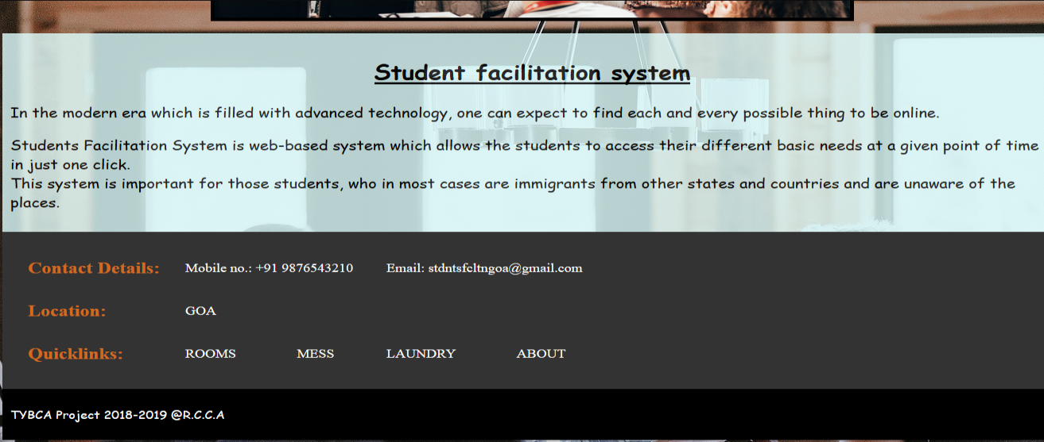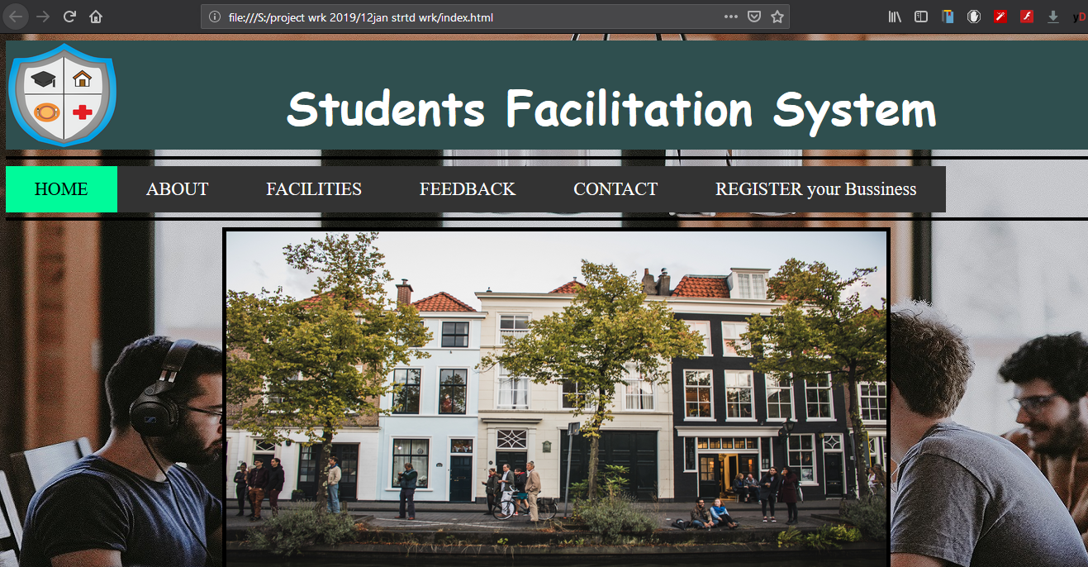**Form Functionality: Home page**

HHHomFGDFF

Screen shot No: 5.1: Home page

|  |  |
| --- | --- |
| **Home :** | Links to home page. |
| **About:** | Links to About page. |
| **Facilities:** | Links to facilities page. |
| **Feedback :** | Links to feedback page. |
| **Contact:** | Links to contact page. |
| **Register your business :** | Links to business registration page |

**Form:II**

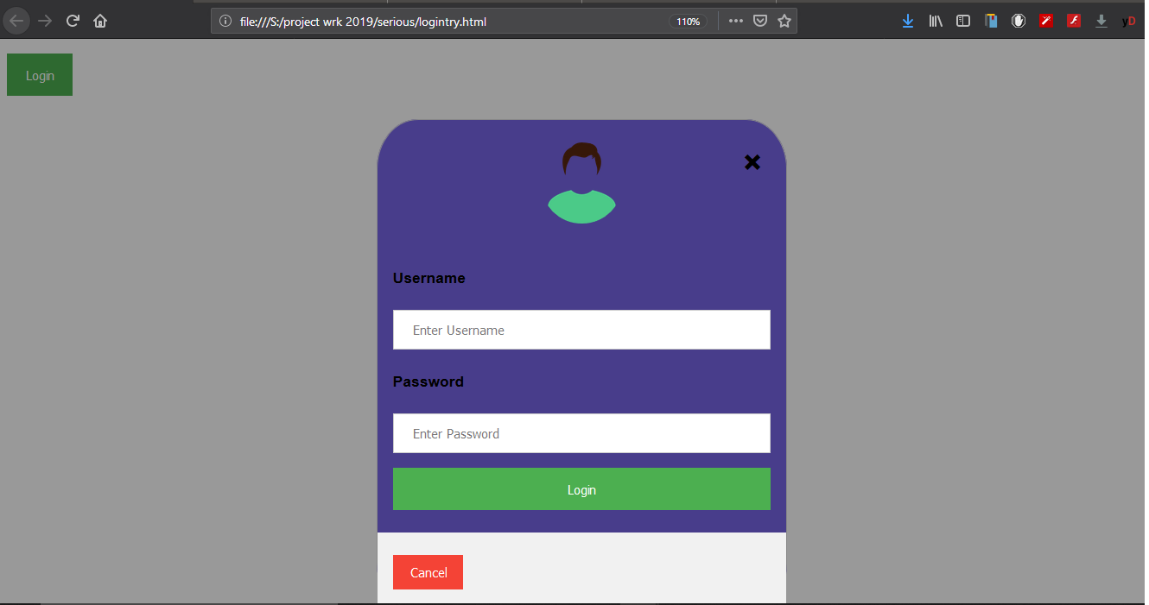**Form Functionality: Administrator Login**

Screen shot No: 5.2: Web Page for the Administrator Login

|  |  |  |
| --- | --- | --- |
| **Username:** | [Alphabets]* | Used to input username of the student |
| **Password :** | [Alphanumeric]* | Used to input password of the student |

**Form:III**

**Form Functionality: Business registration**

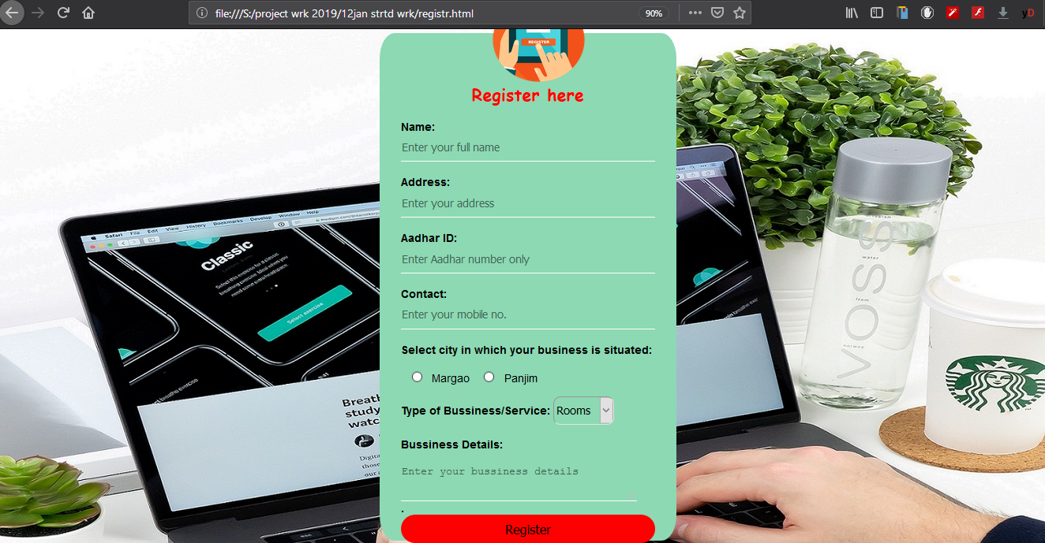

Screen shot No. 5.3:Web page to register Business/Service

|  |  |  |
| --- | --- | --- |
| **Name:** | [Alphabets]* | Used to input name of business person |
| **Address :** | [Alphanumeric]* | Used to input address of the business person |
| **Aadhar ID:** | [Alphanumeric]* | Used to input aadhar Id of the business person |
| **Contact :** | [Numeric]* | Used to input contact of business person |
| **Select City :** | [Option]* | Used to select the city |
| **Business Type:** | [Option]* | Used to select type of business |
| **Business Details:** | [Alphabets]* | Used to input details of business |

**Form:IV**

**Form Functionality: Room Booking**

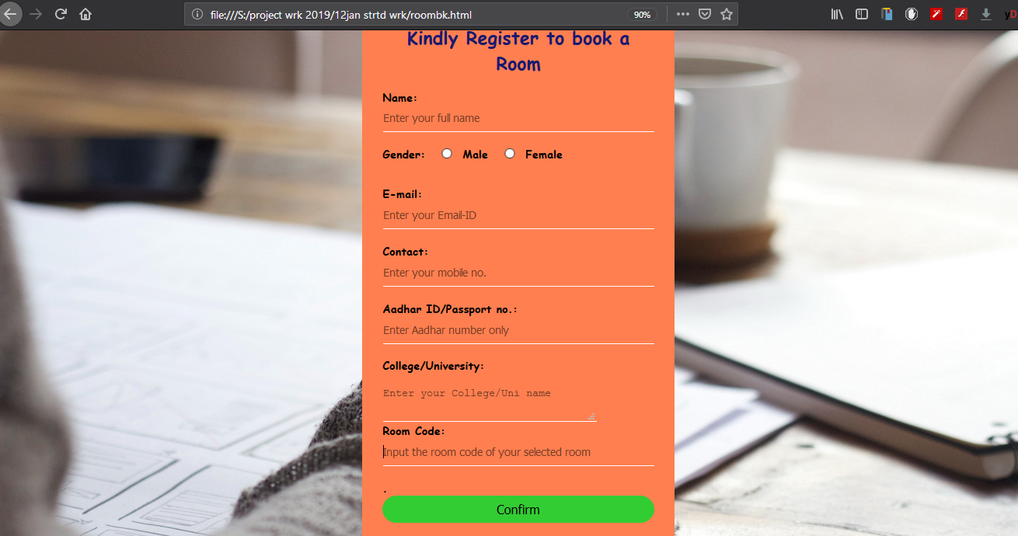

Screen Shot No. 5.4: Web Page for Booking a room.

|  |  |  |
| --- | --- | --- |
| **Name:** | [Alphabets]* | Used to input name of Student |
| **Gender:** | [Radio]* | Used to select the gender of student |
| **E-mail ID:** | [Alphanumeric]* | Used to input Email Id of student |
| **Contact:** | [Numeric]* | Used to input contact of student |
| **Aadhar ID/Passport No:** | [Alphanumeric]* | Used to input aadhar Id/passport number of student |
| **College/University :** | [Alphabets]* | Used to input details of college/University |
| **Room code :** | [Option]* | Used to select the room code |

**Form:V**

**Form Functionality: Laundry Service booking.**

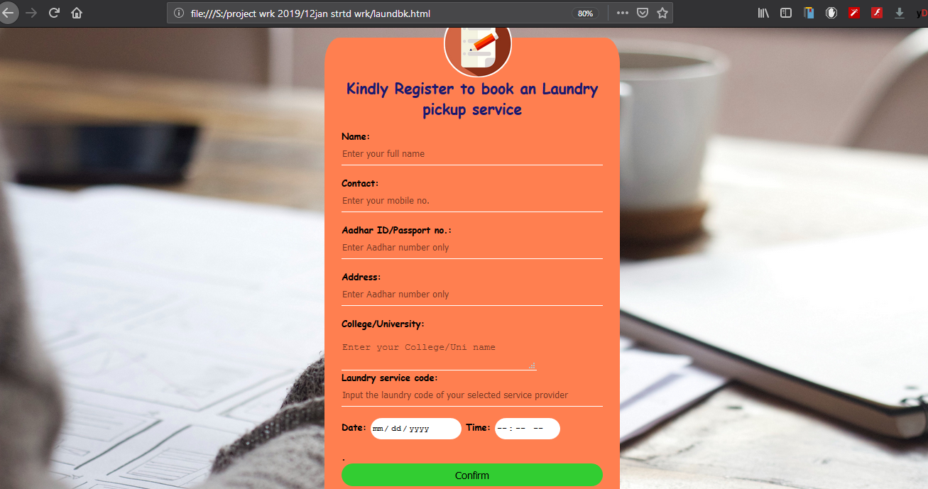

Screen Shot No. 5.5: Web Page for Laundry booking.

|  |  |  |
| --- | --- | --- |
| **Name:** | [Alphabets]* | Used to input name of Student |
| **Contact:** | [Numeric]* | Used to input contact of student |
| **Aadhar ID/Passport No :** | [Alphanumeric]* | Used to input aadhar Id/passport number of student |
| **Address:** | [Alphanumeric]* | Used to enter the details of address |
| **College/University:** | [Alphabets]* | Used to input details of college/University |
| **Laundry service code:** | [Option]* | Used to select the service code |
| **Date:** | [Select]* | Used to select the date |
| **Time :** | [Select]* | Used to enter the time for pickup. |

**Form:VI**

**Form Functionality: Mess booking.**

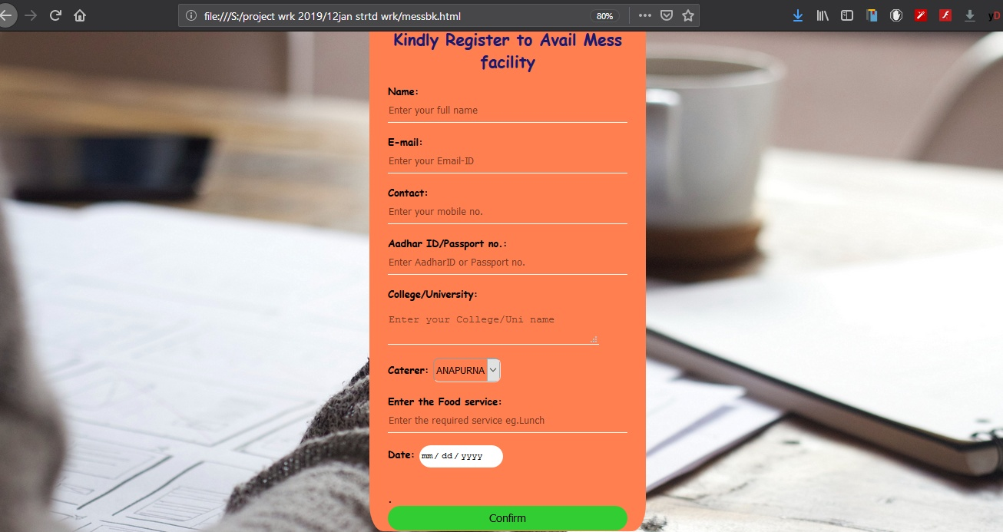

Screen Shot No.5.6: Web Page for Mess booking.

|  |  |  |
| --- | --- | --- |
| **Name:** | [Alphabets]* | Used to input name of Student |
| **E-mail ID :** | [Alphanumeric]* | Used to input Email Id of student |
| **Contact:** | [Numeric]* | Used to input contact of student |
| **Aadhar ID/Passport No:** | [Alphanumeric]* | Used to input aadhar Id/passport number of student |
| **College/University:** | [Alphabets]* | Used to input details of college/University |
| **Caterer :** | [option]* | Used to select the caterer |
| **Enter the food service :** | [Alphanumeric]* | Used to enter service required by the student |
| **Date:** | [Select]* | Used to select the date |

**Chapter 6**

**FUTURE ENHANCEMENT**

This project was taken up as a part of our degree programme and was to be covered in a period of 8 months. Keeping in mind the time constraints and our own capabilities, we reserved certain features to be implemented at a later stage.

They are listed below:

* **Online Payments**

Students will be able to make payments or do online transactions through net banking or using debit or credit cards instead of going personally and paying cash.

**Chapter 7**

**CONCLUSION**

This project is an outcome of our study regarding the facilities available to students studying in Goa. We took up this project with the aim of bringing together the students necessary requirements under one roof thereby overcoming the limitations of the existing systems.

Initially, the system study started with the system analysis phase. The first task we began was looking out for different websites with information about facilities in Goa available on the internet. Information which was extracted from different websites conveyed to us the drawbacks and ambiguities in the current system.

After analyzing the complete system we outlined the database that would store the vital data of the students and the owners. We recommended a web based application with a user friendly interface for checking the different facilities available, to give their feedback and also to ask queries.

**REFERENCES**

* Charles Wyke-Smith(2013), Styling with CSS. New Delhi: Freindsfed.
* Craig Grannell (2007), The Essential Guide to CSS and HTML Web Design. New Delhi: Apress.
* David Sklar (2004), Learning PHP 5. New Delhi: Sitepoint.
* Jennifer Niederst Robbins(2012), Learning Web Design. New Delhi: Wrox.
* Luke Stevens (2012-13), The Truth About HTML5. New Delhi:KnowledgeHut.
* Steven Holzner (2007) , PHP: The Complete Reference. New Delhi: O’Reily.
* W. Jason Gilmore (2010), Beginning PHP and MySQL: From Novice to Professional. New Delhi: Codecacademy.
* [https://www.w3schools.com/html/default.asp,”HTML Tutorials”] Retrieved on 18th August 2018 from https://www.w3schools.com
* [https://www.w3schools.com/css/default.asp,”CSS Tutorials”] Retrieved on 20th October 2018 from https://www.w3schools.com
* [https://www.w3schools.com/js/default.asp,”Javascript Tutorials”] Retrieved on 23rd December 2018 from https://www.w3schools.com
* [https://www.w3schools.com/php/default.asp,”PHP Tutorials”] Retrieved on 21st January 2019 from https://www.w3schools.com

**Annexure**

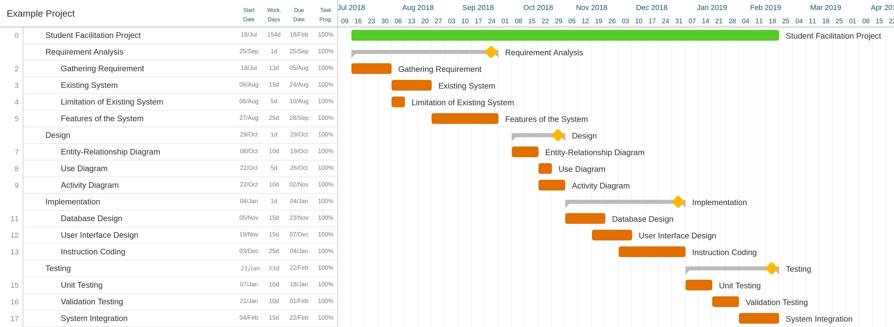**GANTT CHART**